**Definition of Online Display Marketing**

Display marketing is a form of marketing that conveys a commercial message visually using text, logos, animations, videos, photographs, or other graphics. Display advertisers frequently target users with particular traits to increase the ads’ effect.

It is an online form of advertising that the company's promotional messages appear on third party sites or search engine results pages such as publishers or social networks. The main purpose of display advertising is to support a brand awareness and it also helps to increase a purchase intention of consumers.

**How do advertisers know who to target?**

In order to uniquely identify anonymous users, online advertisers today tend to make use of cookies, which are unique identifiers of specific computers, to decide which ADs to serve to a particular consumer. Cookies can track whether a user left a page without buying anything, so the advertiser can later retarget the user with ADs from the site the user visited.

As advertisers collect data across multiple external websites about a user’s online activity, they can then combine this information to create a picture of the user’s interests to deliver even more targeted advertising. This aggregation of data is called behavioral targeting. Advertisers can also target their audience by using contextual and semantic advertising to deliver display ADs related to the content of the web page where the ADs appear. Retargeting, behavioral targeting, and contextual advertising all are designed to increase an advertiser’s return on investment, or ROI, over untargeted ads.

As advertising needs become more sophisticated, display ADs can also be personalized based on a user’s geography through geotargeting. Basic information such as a user’s IP address can indicate a user’s rough location with a limited degree of accuracy. This information can be supplemented further through the use of a phone’s GPS or the location of nearby mobile towers to have a clearer indication of the user’s current position for a mind boggling array of advertising possibilities.

HOW IS MY, **DISPLAY ADVERTISING CAMPAIGN DOING?**

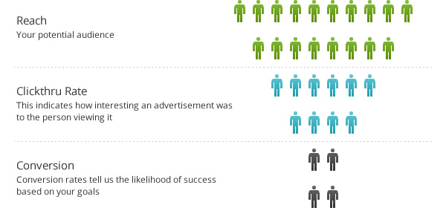

**What is used to measure the success of Display Marketing?**

If your organization intends to activate Display Advertising, it is important to understand some key metrics that you will encounter throughout your engagement process such as Reach, Clickthrough rates, Bounce rates, Conversion rates and of course return on Investment in order to have a better picture of the performance of your Online Display Marketing activities.

**Reach**

Reach for online advertisements are defined by the number of people who can potentially view your advertisement online. Typically this will be represented by the number of visitors that visit the advertisement network you are planning to use.

**Clickthrough Rate (CTR)**

Typically, when we talk about online marketing, a clickthrough rate refers to the likelihood of a user clicking on your online initiative. This is generally used as a benchmark by advertising agencies to gauge how well an advertisement or a campaign is received by the audience.

**Bounce Rate (BCR)**

Bounce rate is the percentage of visits that go only to one page before exiting the site.

When a user bounces on a page that was advertised by a display advertisement, it indicates that the user was intrigued enough to click on the advertisement, but when they visited your site, they found that what they saw on the advertised page is not relevant to them.

There are a number of factors that contribute to your bounce rate. For example, visitors might leave your site from the entrance page if there are site design or usability issues. Alternatively, visitors might also leave the site after viewing a single page if they were not able to find what they were expecting.

**Conversion Rate (CVR)**

The conversion rate basically tells you what percentage of the people clicking through an AD ended up completing an action or a goal that the advertiser desired. This could be anything from a purchase made online, a registration for a newsletter or even a request for more information.

**Return on Investment (ROI)**

When brands embark on display marketing, there is always a cost involved together with a goal to be achieved.

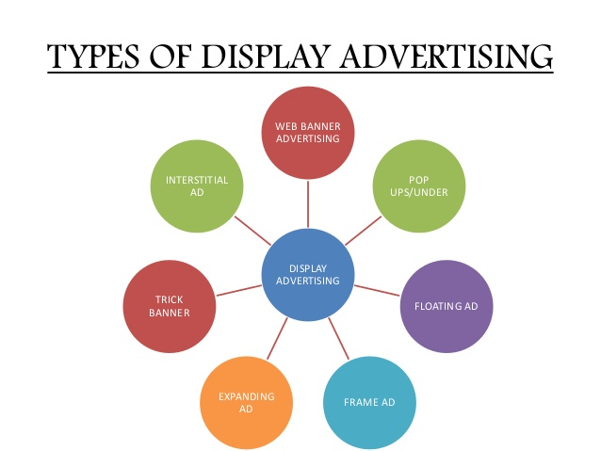

# - **Banner Advertising**

Banner advertising refers to the use of a rectangular graphic display that stretches across the top, bottom or sides of a website. The former type of banner advertisement is called a leaderboard, while the latter is called a skyscraper and is positioned on a web page's sidebars. Banner ads are image-based rather than text-based and are a popular form of online advertising. The purpose of banner advertising is to promote a brand and/or to get visitors from the host website to go to the advertiser's website.

Banner advertising functions mainly the same way as traditional advertising, however, the method by which the advertiser pays the host can differ greatly from traditional ad space sales. The host is paid for the banner advertisement through one of three methods: cost per [impression](https://www.investopedia.com/terms/i/impression.asp) (payment for every website visitor who sees the ad), [cost per click](https://www.investopedia.com/terms/c/cpc.asp) (payment for every website visitor who clicks on the ad and visits the advertiser's website) or cost per action (payment for every website visitor who clicks on the ad, goes to the advertiser's website and completes a task, such as filling out a form   
  
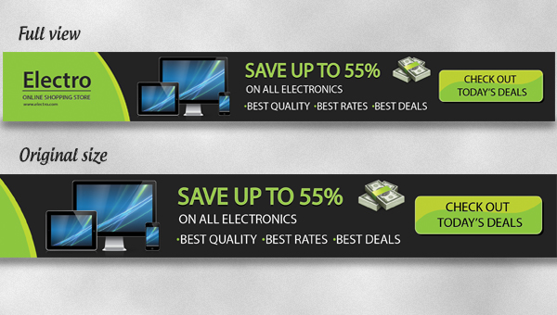

# -POP-UP/POP-UNDER

**Pop-up ads** or **pop-ups** are forms of [online advertising](https://en.wikipedia.org/wiki/Online_advertising) on the [World Wide Web](https://en.wikipedia.org/wiki/World_Wide_Web).[[1]](https://en.wikipedia.org/wiki/Pop-up_ad#cite_note-1) A pop-up is a [graphical user interface](https://en.wikipedia.org/wiki/Graphical_user_interface) (GUI) display area, usually a small window, that suddenly appears ("pops up") in the foreground of the visual interface. The pop-up window containing an advertisement is usually generated by [JavaScript](https://en.wikipedia.org/wiki/JavaScript) that uses [cross-site scripting](https://en.wikipedia.org/wiki/Cross-site_scripting) (XSS), sometimes with a secondary payload that uses [Adobe Flash](https://en.wikipedia.org/wiki/Adobe_Flash).[[2]](https://en.wikipedia.org/wiki/Pop-up_ad#cite_note-mozilla-noscript-2) They can also be generated by other [vulnerabilities/security holes](https://en.wikipedia.org/wiki/Vulnerability_(computing)) in [browser security](https://en.wikipedia.org/wiki/Browser_security). Pop-ups can be used to display [advertisements](https://en.wikipedia.org/wiki/Advertising).

A variation on the pop-up window, the **pop-under** advertisement, opens a new browser window under the [active window](https://en.wikipedia.org/wiki/Active_window). Pop-unders do not interrupt the user immediately, but appear when the user closes the covering window, making it more difficult to determine which website created them.

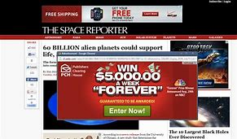

# -**FLOATING ADS**

A floating ad is a type of [rich media](https://whatis.techtarget.com/definition/rich-media) Web advertisement that appears uninitiated, superimposed over a user-requested page, and disappears or becomes unobtrusive after a specific time period (typically 5-30 seconds). The most basic floating ads simply appear over the Web page, either full screen or in a smaller rectangular window. They may or may not provide a means of escape, such as a close button. More sophisticated versions can come in any shape or size and include sound, animation, and interactive components. Floating ads use a variety of technologies, such as a combination of [Flash](https://whatis.techtarget.com/definition/Flash) and dynamic HTML (DHTML), and may have the ability to display differently according to the user's browser capabilities.

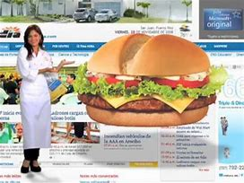

# **-Interstitial Ads**

Interstitial ads are one of the most popular mobile ad formats used by indie developers because of their high impression rate to increase downloads and revenue. Interstitial ads are full-screen ad formats covering the interface of an app and appearing at natural app transition points like pausing a game. Users have the option to skip the ad if they want. The main difference between a banner ad and an interstitial ad is that interstitial ads cover all the screen, and it makes it catchier and more effective.

Developers prefer interstitial ads because of many reasons. Here are the reasons marketers and developers choose interstitial ads.

* Interstitial ads have higher click-through rates than banner ads because of their sizes and bigger impressions on users. Users have 2 options; they will either click the ad or skip the ad to return to the app.
* Developers have larger screen real estate to convince people to take an action on the ad, thanks to more compelling and convincing visuals.

